Malta

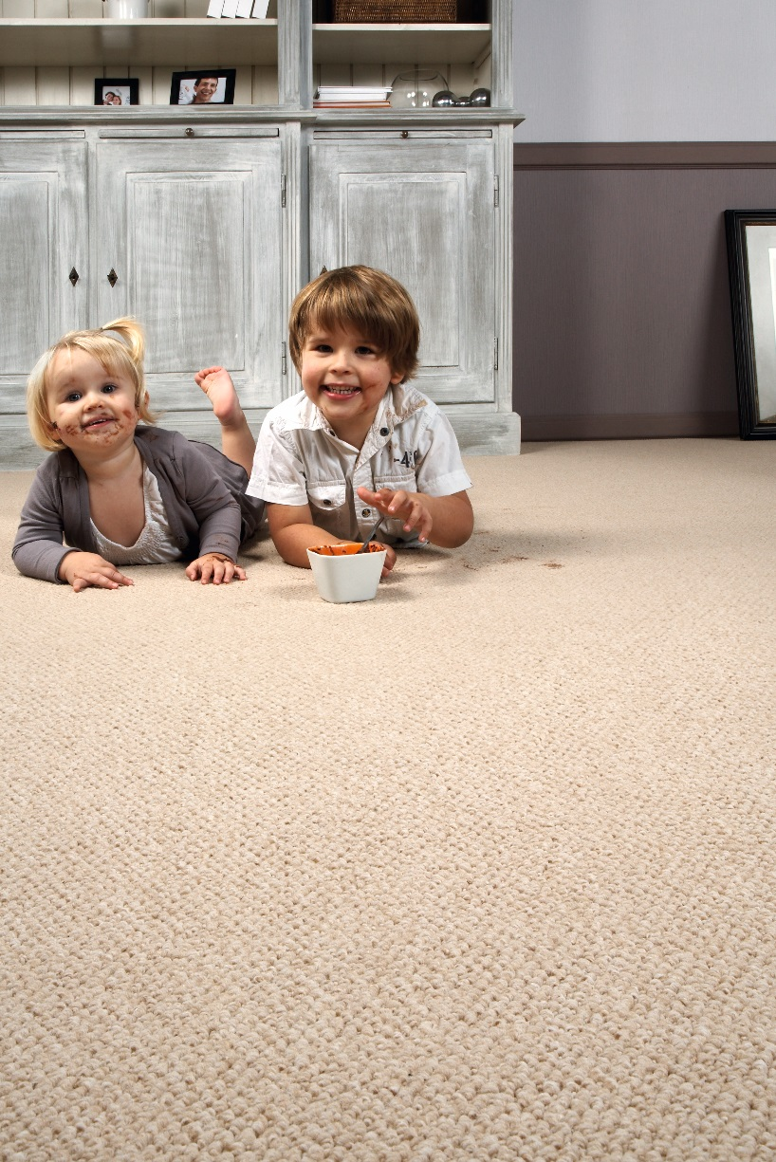
Manufacturing process
Tufting 5/32” loop pile
Pile content
100 % PP
Backing
Felt
Pile weight
ca 540 gr./m²
Total weight
ca 1100 gr./m²
Pile height
ca 3 mm
Total height
ca 5 mm
Tuft density
ca 107 100/m²
Width
400 cm

